Understanding Structs in C#
What is a Struct?
A struct in C# is a value type that is primarily used to create lightweight objects that represent data. Structs are often used when the size of the data is small, and the object does not require complex behaviors or inheritance. A struct can be thought of as a custom data type.
Struct
- Purpose:
  - Struct: Used exclusively for data representation.
- Memory Allocation:
  - Struct: Allocated on the stack.
- Type:
  - Struct: Always a value type.
- Usage:
  - Use struct when the data size is small, and the object does not require inheritance or polymorphism.
Access Modifiers in Structs
Inside a struct, you can use the following access modifiers:
- public
- private
- internal
Struct Constructor
- Definition:
  - A constructor in a struct is a special method used to initialize the data fields of the struct.
- Behavior:
  - A struct generate a parameterless constructor by default.
  - Struct constructors must always initialize all fields before the constructor completes.
- Non-Private Restriction:
  - A struct constructor cannot be private because structs are value types and need to be initialized explicitly or implicitly.

The this Keyword in Struct Constructors
- The ‘this’ keyword in a struct constructor refers to the current instance of the struct.
- It is used to assign values to the struct’s fields during initialization.
Using new with Structs
- Struct:
  - The new keyword chooses the constructer I want to use while initialization the Object.
Inheritance and Structs
- Structs cannot inherit from classes.
- Structs can implement interfaces, which allows them to inherit behaviors defined in the interface.
Constructor Overloading in Structs
- Structs support constructor overloading, allowing multiple constructors with different parameter sets to initialize the struct in various ways.
Summary Points
- Use structs for small, lightweight data types.
- Structs are value types, while classes are reference types.
- Structs cannot inherit from classes but can implement interfaces.
- Struct constructors must initialize all fields.

Understanding Object-Oriented Programming (OOP)

What is OOP?
Object-Oriented Programming (OOP) is a programming paradigm centered around the concept of "objects," which represent real-world entities. Each object contains data (fields/properties) and behaviors (methods/functions), enabling a modular and reusable approach to system design.

Working with Systems as Business Objects
In OOP, systems are often modeled as business objects to reflect real-world entities. For example:
- A "Customer" object may have properties like Name and Address and methods like PlaceOrder or UpdateProfile.
- A "Product" object may have properties like Price and Stock and methods like ApplyDiscount or Restock.
This approach makes code intuitive, maintainable, and aligned with business processes.

The Four Pillars of OOP

1. Encapsulation
Encapsulation is the process of bundling data and methods that operate on that data into a single unit (class or object) and restricting access to certain components.

Benefits:
- Protects the integrity of the object’s state by exposing only necessary details through public methods or properties.
- Hides implementation details, promoting modularity and security.

Problems Without Encapsulation:
- External code can directly modify internal fields, potentially corrupting the object’s state.
- Changes in implementation require updates across the entire codebase, reducing maintainability.

2. Inheritance
Inheritance enables a new class (child) to inherit properties and behaviors from an existing class (parent), creating an "is-a" relationship.

Key Points:
- C# supports single inheritance, where a class can inherit from only one parent class.
- Inheritance promotes code reuse and a hierarchical class structure.

3. Polymorphism
Polymorphism allows objects to take many forms, enabling a unified interface for different implementations.

Types:
- Overloading: Defining multiple methods with the same name but different parameter sets within the same class (compile-time polymorphism).
- Overriding: Redefining a method in a child class that already exists in the parent class to provide specific behavior (runtime polymorphism).

4. Abstraction
Abstraction simplifies complex systems by exposing only the essential features and hiding implementation details. This is often achieved through:
- Abstract classes: Provide a base definition for subclasses.
- Interfaces: Define contracts that implementing classes must fulfill.

Summary Points
- OOP models systems as objects representing real-world entities.
- Encapsulation protects object integrity and promotes modularity.
- Inheritance enables code reuse and hierarchy.
- Polymorphism allows for flexible, reusable code.
- Abstraction simplifies system design by focusing on essential details.

Encapsulation in Object-Oriented Programming (OOP)
Encapsulation is a fundamental principle of Object-Oriented Programming (OOP) that combines data and the methods that operate on that data into a single unit. It restricts direct access to some of the object's components, which is essential for maintaining the integrity of the data and controlling its behavior through well-defined interfaces.

Private Fields and Access Through Getters and Setters

Private Fields
In OOP, fields (variables) within a class are often declared as private to prevent external access. This ensures that the internal state of an object cannot be modified directly, maintaining the integrity of the data.

Working with Getters and Setters
To allow controlled access to private fields, getter and setter methods are used. These methods provide a mechanism to retrieve and update the values of private fields while allowing additional logic to be applied.

Example:
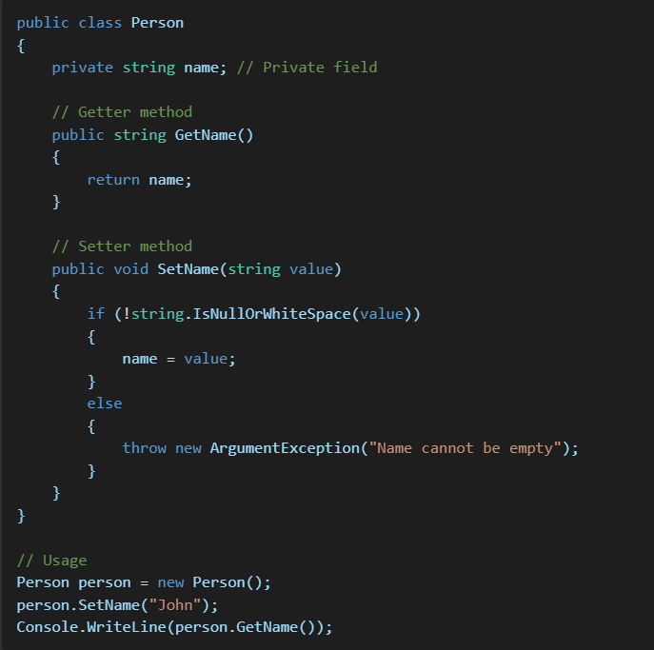

Encapsulating Fields with Properties
C# introduces properties as a more elegant way to encapsulate fields, replacing the need for explicit getter and setter methods. Properties are declared using the get and set accessors.

Example of Properties:
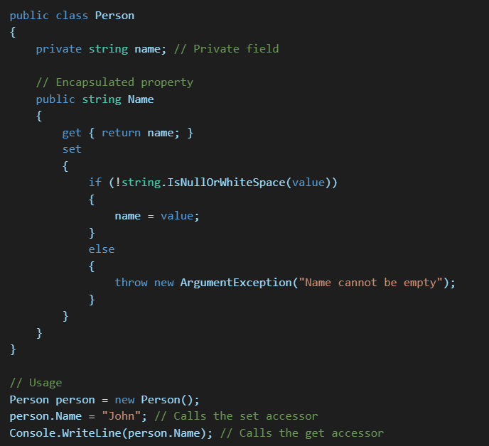

Automatic Properties
In scenarios where no additional logic is needed, C# provides a shorthand for creating properties known as automatic properties. These automatically generate a private backing field.

Example of Automatic Properties:
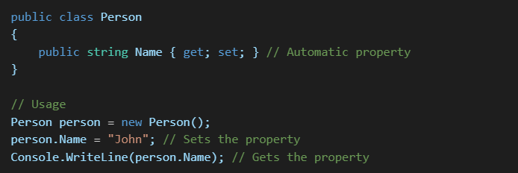

Indexer
What is Indexer
Indexer Is a Special Property Named with The Keyword “this” And Can Take Parameters
This Allows Instance of a class or struct to be indexed like arrays.

How To Create Indexer ?
